Activity: 3D print a custom keychain

1. Create a single letter in a word processing app, in a large font. Pick a style you like. You can use drawing programs too, if you are comfortable with that. Here’s an example:

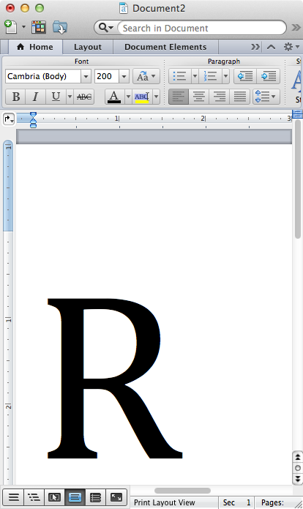

1. Use Grab (MacOS) or Snipping Tool (Windows) to capture as a jpg format. If on a Mac, you will need to convert from a tiff to a jpg, you can use Preview for that.
2. (Optional) Open the jpg in Gimp or other image editing software and edit the image to create a hole for the keyring. Here’s an example:

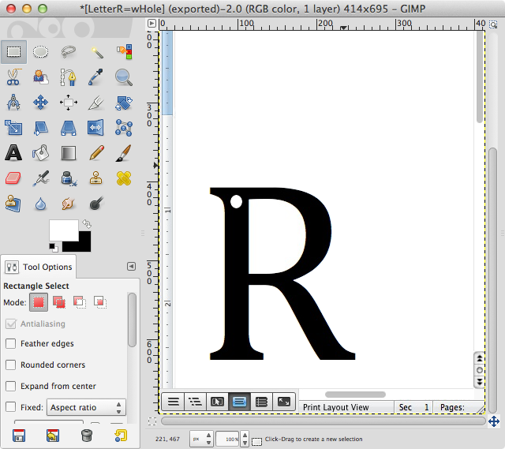

1. Crop image to eliminate all graphics except for your design. Export (or save) to jpg.

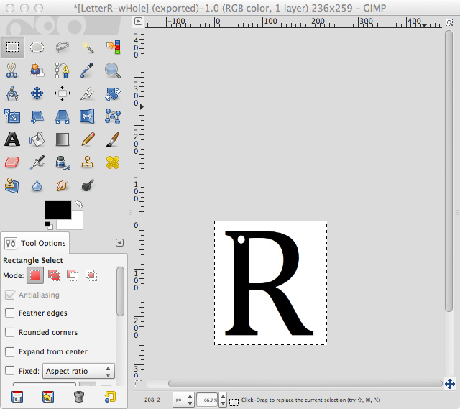

1. Create an account and login at <https://www.shapeways.com>
2. Navigate to *Make Your Own* -> *2D to 3D* on the menu bar
3. Fill out the form. Select your jpg file and fill in the dimensions. Here’s an example:

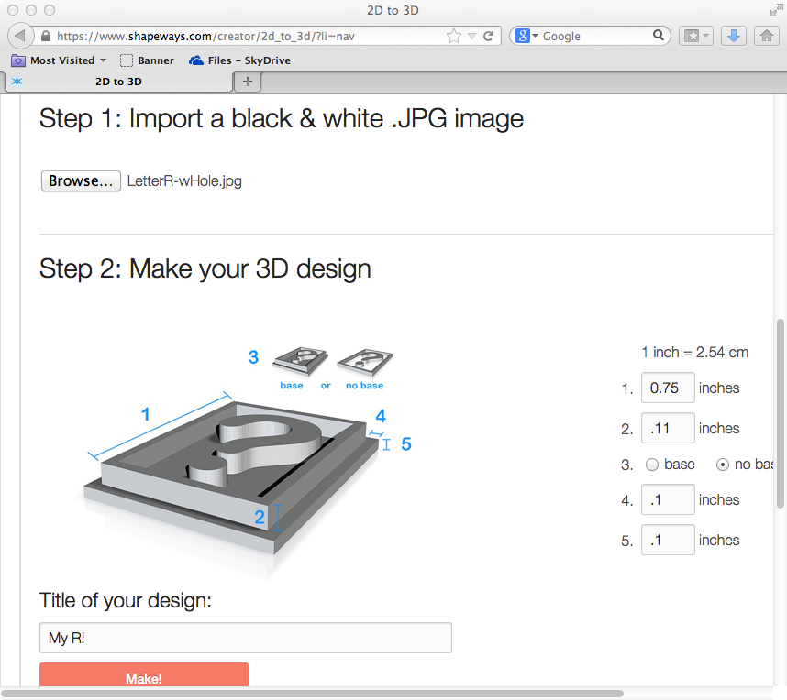

1. You should see the following confirmation:

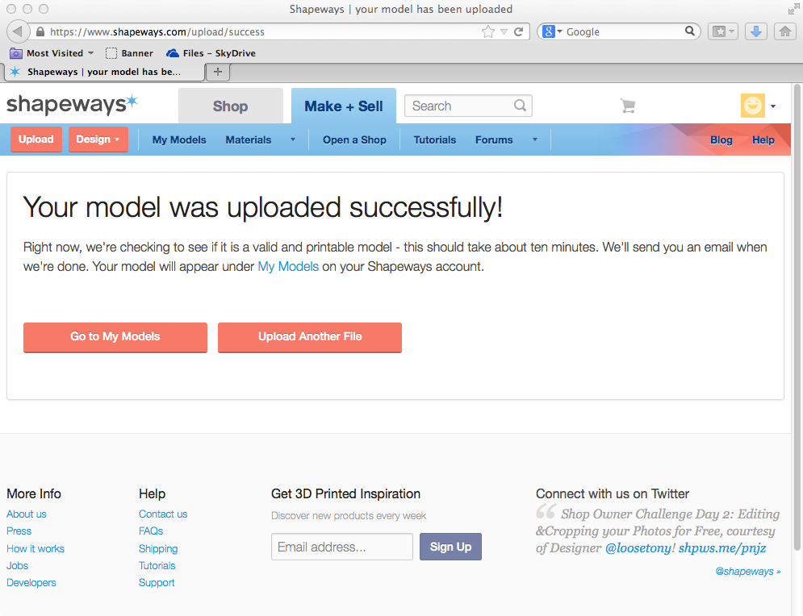

1. Wait for the confirmation email.
2. Navigate to My Models, click on your model:

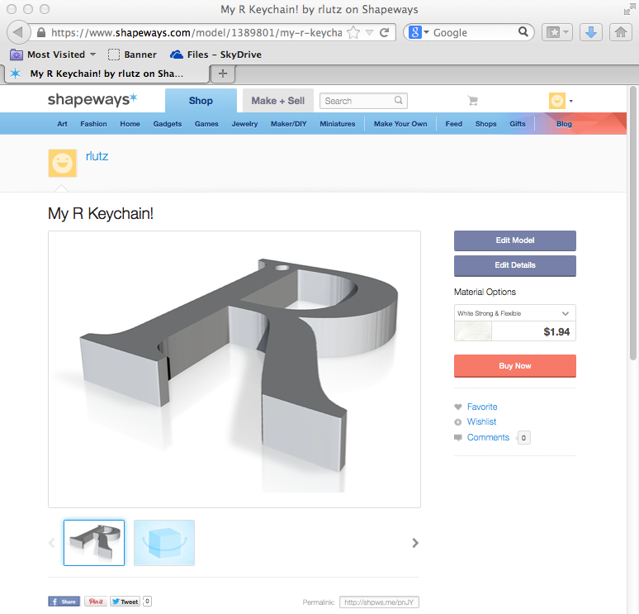

1. Success! Pick a material, enter your credit card, look for the UPS truck or:

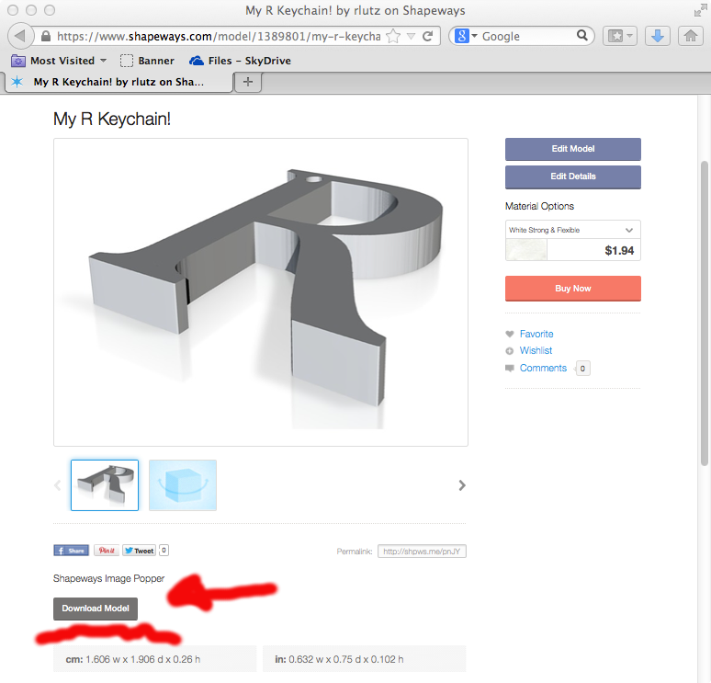

1. We’ll use this stl file later.